**ENGR 301**

**Engineering Management Principles and Economics**

**Tutorial 6: Economic Equivalency**

1. An individual deposits an annual bonus into a savings account that pays 8% interest compounded annually. The size of the bonus increases by $2000 each year, and the initial bonus amount was $5000. Determine how much will be in the account immediately after the 5th deposit.
2. Compute the value of P in the accompanying cash flow diagram, assuming that i=9%.

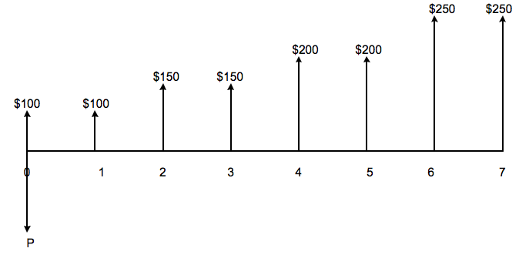

1. The two cash flow transactions shown in the accompanying cash flow diagram are said to be equivalent at 6% interest compounded annually. Find the unknown value of X that satisfies the equivalence.

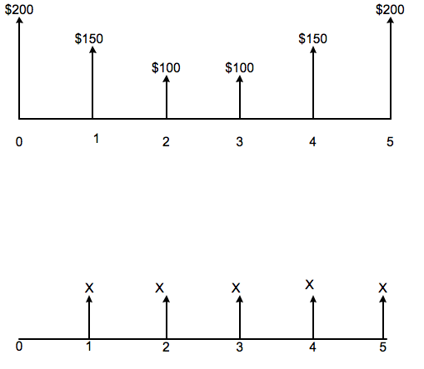

1. From the accompanying cash flow diagram, find the value of C that will establish the economic equivalence between the deposit series and the withdrawal series at an interest rate of 8% compounded annually.

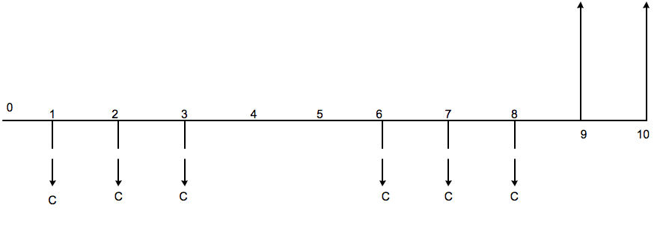

1. John Jay is purchasing a $24,000 automobile, which is to be paid for in 48 monthly installments of $543.35. What effective annual interest is he paying for his financing arrangement?